**Reneal 2024B Box and Project Notes**

**Version 1**

IMPORTANT NOTES

1. Eleven new schools:
   1. Mbeya Region: Ikuti, Kinyala, Lupoto, Mpuguso
   2. Kilimanjaro Region: Namwai, Sanya Juu, Nuru, Oshara
   3. Iringa: Uhambingeto
   4. Dodoma: Viwandani
   5. Manyara Region: Manyara Girls (some boxes for Manyara Girls are marked “Olmoti”)
2. Ten of the new servers have 16.04+webdev+wireless. Please watch the video (<https://drive.google.com/file/d/1NTW8NvalmSxi2fIHIZJ83J-87Zmv8r4h/view?usp=drive_link>) about how to set up these servers and use the Reneal wireless, and share this with the SUs. For the new servers with the Reneal wireless, it is difficult to unplug the Reneal wireless router from the server LAN connection. The small plastic “latch” on the RJ45 is hard to reach. Please tell the SU to not pull it out, that will break the latch. They must use a plastic card like an ATM card or a piece of cardboard to reach in and push down the latch, so the RJ45 can be removed safely. Please watch the video showing how to connect and disconnect. Also note that to use the Reneal Wireless system with a cell phone, it may be necessary to turn off mobile data on the cell phone.
3. The Manyara Girls server (a micro desktop) has 16.04+webdev but does not include wireless. There is another video (<https://drive.google.com/file/d/1s8P6qixZad86HETDjdiVzKtdkajxiW39/view?usp=drive_link>) showing how to set up the Manyara Girls micro desktop server.
4. For the 16.04+webdev+wireless systems, the server MUST be plugged into the network switch for the virtual machines to work. If the server is not plugged into the network switch, Kolibri will not start and the webdev system will not work.
5. This shipment includes 11 extra wireless routers. These should be stored in the warehouse to be used for the 2025 Phase 1 schools (for Reneal Wireless).

General Notes

1. There are no mice for the laptops in this shipment. The ecolevy was too expensive to ship mice to the schools. There is only one mouse per school, for the server.
2. Please collect any equipment donated by Apto that has failed and save it at the Reneal office. We must return any dead items to Apto Solutions for recycling if we cannot fix them.
3. Each TIB kit has everything needed for a TIB installation. Please note that the wireless signal for the TIB system is “LAB_2G” and not “TIB_2G”.

Summary of Box Contents

1. Here is the organization of the boxes:
   1. Boxes A-T have laptops/adapters, and a keyboard and a mouse for each of the first 10 new schools. There are two boxes per new school (total of 20 boxes).
   2. Box U has 12 laptops/adapters for the 11th school – the remaining 8 laptops must be taken out of the warehouse.
   3. Box V has the micro desktop for the 11th school that will be the server, its adapter, an adapter for the UPS, a video adapter cable, the mouse and keyboard, and the sysadmin manual with donation letters. There are also two TIB kits and four wireless routers for the 2025A shipment in Box V. Put the 2025A wireless routers in the Reneal warehouse, until the 2025A shipment arrives.
   4. Box W has the network switches for 8 of the new schools (NOTE: the network switches are no longer in the boxes with the servers!)
   5. Box X has the network switches for the remaining 3 new schools. There are also 7 wireless routers for the 2025A shipment in Box X. Put the 2025A wireless routers in the Reneal warehouse, until the 2025A shipment arrives.
   6. Boxes AA, BB, CC, DD, EE have the following:
      1. Servers for the 10 new schools (two per box).
      2. The power cable for the server and the sys admin manual are inside each server box. Two copies of the donation letter are inside the sys admin manual.
   7. Boxes FF, GG, HH, and II have monitor screens/stands/bases/VGA cables/power cables per box (one for each new school plus 3 spares to put in the Reneal warehouse)
   8. Boxes HH and II have Team Supplies.
   9. Box JJ, KK, LL, and MM have 5 TIB kits per box.
2. All monitors have VGA cables in this shipment.
3. The following boxes have all of the equipment for the 12 new schools:
   1. Ikuti Secondary School: A, B, part of W, part of AA, part of FF
   2. Kinyala Secondary School: C, D, part of W, part of AA, part of FF
   3. Lupoto Secondary School: E, F, part of W, part of BB, part of FF
   4. Mpuguso Secondary School: G, part of W, H, part of BB, part of FF
   5. Namwai Secondary School: I, J, part of W, part of CC, part of GG
   6. Sanya Juu Secondary School: K, L, part of W, part of CC, part of GG
   7. Nuru Secondary School: M, N, part of W, part of DD, part of GG
   8. Oshara Secondary School: O, P, part of W, part DD, part of GG
   9. Uhambingeto Secondary School: part of X, Q, R, part of EE, part of HH
   10. Viwandani Secondary School, S, T, part of X, part of EE, part of HH
   11. Manyara Girls Secondary School, U, part of V, part of X, part of FF, part of HH, [TAKE THE REMAINING 8 LAPTOPS AND ADAPTERS FROM THE WAREHOUSE]
4. Team supplies are in Box HH and II. There is a bag of supplies for each Team member (see below). You are responsible for getting your own supplies when the shipment arrives. There are RJ45 connectors and cable zip ties for Juma for the new installations.

* Each Team member: Blue tape, Sharpie pen, Reneal Team Tanzania business cards
* James: Poli UPS-power plug adapter to plug server into UPS
* Danny: cable tester, knife, screwdrivers, spudger set, torx 6 screwdriver
* Juma: extra screws for HP monitors, 3 LAN cards to repair HP G650 laptops at Ifati with bent LAN connector pins
* Warehouse: Clear box tape, blue tape, spare crimper, 3 UPS-power cables (Emergency Server #1, Emergency Server #2, spare), 1 bag of RJ45 connectors

Reneal Wireless System

Wifi signal: LAB_2G or LAB_5G (Password 12345678)

Navigate to 10.10.10.1

Teachers may need to turn off mobile data to use the Reneal Wireless on their phones or tablets.

The Reneal Wireless router (use an orange plug) connect to the network interface card in the server that has one port. Tell the SUs to not reconfigure the Reneal wireless router. If they do, the Reneal Wireless will not work. The Reneal wireless router does not provide internet, only the Reneal educational material on the server. If the school has internet, it should be plugged into the LAN connector on the motherboard, as usual.

Arusha Equipment

|  |  |  |
| --- | --- | --- |
| **Item** | **Purchased** | **Destination** |
| Uninterruptible power supply (UPS) | 11 | All schools |
| Voltage stabilizer, 500VA | 11 | All schools |
| Power universal extensions (5 outlets) | 55 | 5 each for all schools |

PLEASE NOTE: We will purchase 6 boxes of UTP cable. The extra cable should be stored in the warehouse.

Installation Notes

Here is a list of what you will need at each new school being installed: server, power cord for server, sysadmin manual and donation letters, keyboard, monitor screen, monitor stand (2 pieces), power and video cables for monitor, network switch and power cord, 20 laptops, 20 laptop adapters, 1 mouse, a wireless router with power adapter and Ethernet cable, UPS, 3 special UPS cords OR a multiplug (for server, monitor, and network switch), voltage stabilizer, 5 extensions, Cat6 cable, RJ45 connectors, zip ties, blue tape, pens, cable clips, screws for mounting the switch, hammer and drill, your personal supplies and tools, power meter, and Reneal T-shirts.

[Note that the 11th school is using a micro desktop as the server. It will also need a power adapter, UPS-to-power adapter, USB-to-LAN adapter, and a DisplayPort-to-VGA video cable adapter. Watch the video to see how it is connected.]

1. Please use the installation checklist to make sure all steps are completed and you gather all the needed information about the new school plus the signed donation letters.
2. PLEASE NOTE: UPS should be charged for 12 hours before it is used the first time.
3. Before you plug anything in, check the computer room voltage with the power meter to make sure it is around 220 volts and stable.
4. If the server does not start properly, take off the cover and check the power connectors to the motherboard, check any SATA cables, make sure the RAM is inserted fully, and check the network cards to make sure they are inserted completely. The main storage device is now an Nvme stick attached to the motherboard, so they should not need to be checked since they are firmly attached.
5. I have the specifications for all of the laptops in a spreadsheet. Please leave the blue tape with the number on the laptop, for identification. “AS” with a number means the laptop/adapter was donated by Apto Solutions.
6. For a regular Reneal server with webdev+wireless: The internet, if available, plugs into the motherboard RJ45 connector. The Reneal Wireless router plugs into the network interface card with one port. The network switch has two connections to the server, which plug into the network interface card with two ports.
7. For the micro desktop Reneal server with webdev: The internet plugs into the USB-LAN dongle. The network switch plugs into the micro desktop RJ45 connection. There is no Reneal wireless capability for the micro desktop servers.

Laptop Notes

There are Dell Laptops for Schools 1-10 and a mix of Dell, HP, and Lenovo for School #11.

All of the Dell adapters should work with any Dell laptop, so the adapters are not labeled with a number. For some Dell laptops, you may see a message about the power adapter not providing enough power to charge the battery, or that it can’t identify the power adapter. Please just hit F3, which will disable future warnings. Then hit F1 to continue the boot.

For School #11, the adapters are labeled with the laptop number so they can be connected properly.

Dell E5470 Laptop with dead CMOS battery (Uhambingeto and Viwandani)

Never try to change the CMOS battery for the Dell E5470. It is very difficult.

For most of E5470 laptops with a dead CMOS, you can just do “F1” on boot. However there are 3 units in this shipment (AS-1614, AS-1617, and AS-1621) that seem to have a more recent BIOS and will boot to UEFI and not the network. It will take an extra step to boot these computers. Please read the special instructions below and share with the SUs.

A laptop with a dead CMOS battery will take a long time to start. The SU can just turn these on and then go do other things, so they don’t have to wait.

Then it will show this screen. You know that the CMOS battery is dead, because the laptop does not know the time or date.

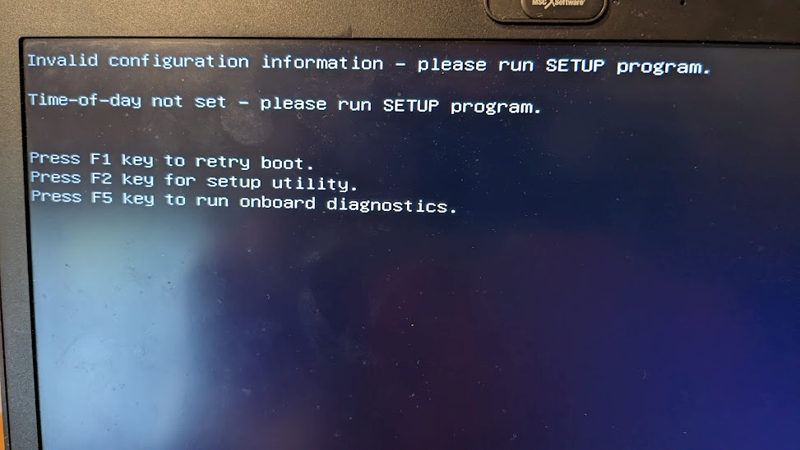

Press F1 to retry the boot

For most of these laptops with a dead CMOS battery, the next screen you see will be this, and the boot has been successful

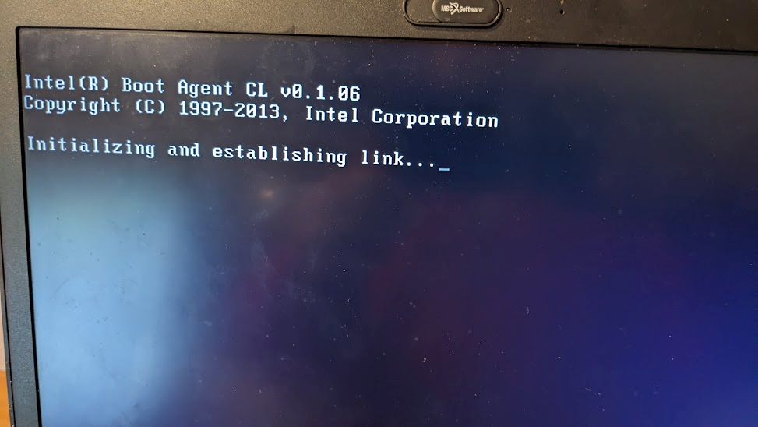

However, there are 3 E5470 units (AS-1614, AS-1617, and AS-1621) that seem a more recent BIOS and will boot to UEFI and not the network. For these units, the screen below comes up. For some reason, it has changed to “UEFI” mode instead of Legacy BIOS. You will need to do more steps to do a successful boot. (This might happen for other units.)

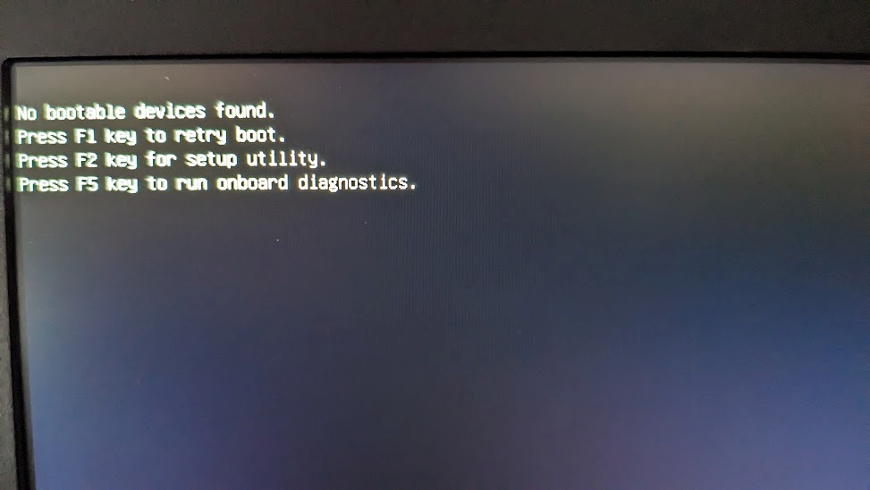

First, reboot the laptop by pressing the CTRL-ALT-DEL keys at the same time.

You will then see the Dell welcome screen. As soon as you see this Dell welcome screen, begin to press the F12 key. You can press it many times.



Pressing the F12 key will give you a “boot option menu”. If you have successfully pressed F12, you will see some yellow text in the upper right-hand corner that says “Preparing one-time boot menu”

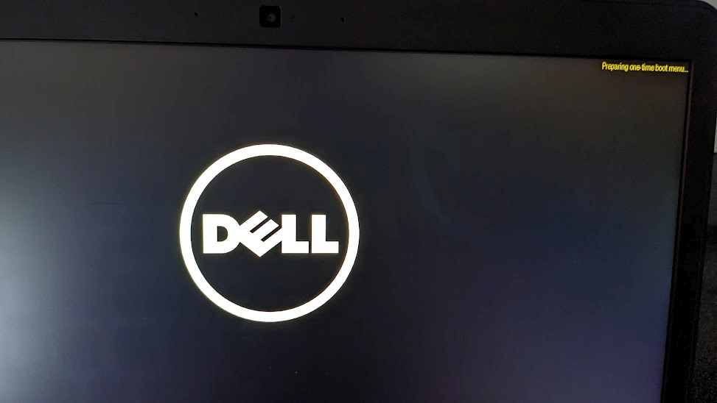

Then you will see the boot options window:

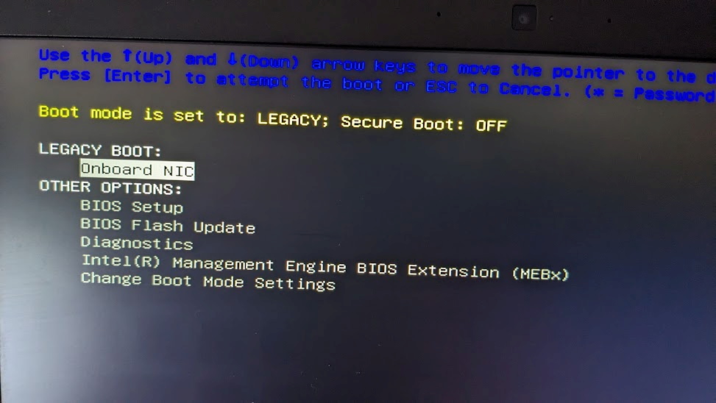

The option you want, “Onboard NIC”, should already be highlighted. Press the Enter key, and you should then get a successful boot.

**Summary:**

**F1**

**If boot not successful:**

**CTRL-ALT-DEL to reboot**

**Press F12 when you see Dell screen**

**Choose “Onboard NIC”**

**Box Contents**

|  |  |  |  |
| --- | --- | --- | --- |
| **Box** | **Item** | **Quantity** | **Destination** |
| A | Laptop | 9 | Ikuti |
| A | Laptop adapter | 20 | Ikuti |
| A | Mouse | 1 | Ikuti |
| A | Keyboard | 1 | Ikuti |
| A | Wireless router | 1 | Ikuti |
|  |  |  |  |
| **Box** | **Item** | **Quantity** | **Destination** |
| B | Laptop | 11 | Ikuti |
|  |  |  |  |
| **Box** | **Item** | **Quantity** | **Destination** |
| C | Laptop | 8 | Kinyala |
| C | Laptop adapter | 20 | Kinyala |
| C | Mouse | 1 | Kinyala |
| C | Keyboard | 1 | Kinyala |
| C | Wireless router | 1 | Kinyala |
|  |  |  |  |
| **Box** | **Item** | **Quantity** | **Destination** |
| D | Laptop | 12 | Kinyala |
|  |  |  |  |
| **Box** | **Item** | **Quantity** | **Destination** |
| E | Laptop | 8 | Lupoto |
| E | Laptop adapter | 20 | Lupoto |
| E | Mouse | 1 | Lupoto |
| E | Keyboard | 1 | Lupoto |
| E | Wireless router | 1 | Lupoto |
|  |  |  |  |
| **Box** | **Item** | **Quantity** | **Destination** |
| F | Laptop | 12 | Lupoto |
|  |  |  |  |
| **Box** | **Item** | **Quantity** | **Destination** |
| G | Laptop | 8 | Mpuguso |
| G | Laptop adapter | 20 | Mpuguso |
| G | Mouse | 1 | Mpuguso |
| G | Keyboard | 1 | Mpuguso |
| G | Wireless router | 1 | Mpuguso |
|  |  |  |  |
| **Box** | **Item** | **Quantity** | **Destination** |
| H | Laptop | 12 | Mpuguso |
|  |  |  |  |
| **Box** | **Item** | **Quantity** | **Destination** |
| I | Laptop | 8 | Namwai |
| I | Laptop adapter | 20 | Namwai |
| I | Mouse | 1 | Namwai |
| I | Keyboard | 1 | Namwai |
| I | Wireless router | 1 | Namwai |
|  |  |  |  |
| **Box** | **Item** | **Quantity** | **Destination** |
| J | Laptop | 12 | Namwai |
|  |  |  |  |
| **Box** | **Item** | **Quantity** | **Destination** |
| K | Laptop | 8 | Sanya Juu |
| K | Laptop adapter | 20 | Sanya Juu |
| K | Mouse | 1 | Sanya Juu |
| K | Keyboard | 1 | Sanya Juu |
| K | Wireless router | 1 | Sanya Juu |
|  |  |  |  |
| **Box** | **Item** | **Quantity** | **Destination** |
| L | Laptop | 12 | Sanya Juu |
|  |  |  |  |
|  |  |  |  |
|  |  |  |  |
| **Box** | **Item** | **Quantity** | **Destination** |
| M | Laptop | 8 | Nuru |
| M | Laptop adapter | 20 | Nuru |
| M | Mouse | 1 | Nuru |
| M | Keyboard | 1 | Nuru |
| M | Wireless router | 1 | Nuru |
|  |  |  |  |
| **Box** | **Item** | **Quantity** | **Destination** |
| N | Laptop | 12 | Nuru |
|  |  |  |  |
| **Box** | **Item** | **Quantity** | **Destination** |
| O | Laptop | 8 | Oshara |
| O | Laptop adapter | 20 | Oshara |
| O | Mouse | 1 | Oshara |
| O | Keyboard | 1 | Oshara |
| O | Wireless router | 1 | Oshara |
|  |  |  |  |
| **Box** | **Item** | **Quantity** | **Destination** |
| P | Laptop | 12 | Oshara |
|  |  |  |  |
| **Box** | **Item** | **Quantity** | **Destination** |
| Q | Laptop | 8 | Uhambingeto |
| Q | Laptop adapter | 20 | Uhambingeto |
| Q | Mouse | 1 | Uhambingeto |
| Q | Keyboard | 1 | Uhambingeto |
| Q | Wireless router | 1 | Uhambingeto |
|  |  |  |  |
| **Box** | **Item** | **Quantity** | **Destination** |
| R | Laptop | 12 | Uhambingeto |
|  |  |  |  |
| **Box** | **Item** | **Quantity** | **Destination** |
| S | Laptop | 8 | Viwandani |
| S | Laptop adapter | 20 | Viwandani |
| S | Mouse | 1 | Viwandani |
| S | Keyboard | 1 | Viwandani |
| S | Wireless router | 1 | Viwandani |
|  |  |  |  |
| **Box** | **Item** | **Quantity** | **Destination** |
| T | Laptop | 12 | Viwandani |
|  |  |  |  |
| **Box** | **Item** | **Quantity** | **Destination** |
| U | Laptop | 12 | Manyara Girls |
| U | Laptop adapter | 12 | Manyara Girls |
| U | Sys Admin Manual | 1 | Manyara Girls |
|  |  |  |  |
| **Box** | **Item** | **Quantity** | **Destination** |
| V | Desktop computer | 1 | Manyara Girls |
| V | Mouse | 1 | Manyara Girls |
| V | Keyboard | 1 | Manyara Girls |
| V | Routers | 4 | For 2025A schools |
| V | TIB kits | 2 |  |
|  |  |  |  |
| **Box** | **Item** | **Quantity** | **Destination** |
| W | Network switch | 8 | Schools 1-8 |
|  |  |  |  |
| **Box** | **Item** | **Quantity** | **Destination** |
| X | Routers | 7 | For 2025A schools |
| X | Network switch | 3 | Schools 9-11 |
|  |  |  |  |
|  |  |  |  |
| **Box** | **Item** | **Quantity** | **Destination** |
| AA | Desktop computer | 1 | Ikuti |
| AA | Desktop computer | 1 | Kinyala |
| AA | Sys admin manual | 1 | Ikuti |
| AA | Sys admin manual | 1 | Kinyala |
|  |  |  |  |
| **Box** | **Item** | **Quantity** | **Destination** |
| BB | Desktop computer | 1 | Lupoto |
| BB | Desktop computer | 1 | Mpuguso |
| BB | Sys admin manual | 1 | Lupoto |
| BB | Sys admin manual | 1 | Mpuguso |
|  |  |  |  |
| **Box** | **Item** | **Quantity** | **Destination** |
| CC | Desktop computer | 1 | Namwai |
| CC | Desktop computer | 1 | Sanya Juu |
| CC | Sys admin manual | 1 | Namwai |
| CC | Sys admin manual | 1 | Sanya Juu |
|  |  |  |  |
| **Box** | **Item** | **Quantity** | **Destination** |
| DD | Desktop computer | 1 | Nuru |
| DD | Desktop computer | 1 | Oshara |
| DD | Sys admin manual | 1 | Nuru |
| DD | Sys admin manual | 1 | Oshara |
|  |  |  |  |
| **Box** | **Item** | **Quantity** | **Destination** |
| EE | Desktop computer | 1 | Uhambingeto |
| EE | Desktop computer | 1 | Viwandani |
| EE | Sys admin manual | 1 | Uhambingeto |
| EE | Sys admin manual | 1 | Viwandani |
|  |  |  |  |
| **Box** | **Item** | **Quantity** | **Destination** |
| FF | Monitor | 4 | Ikuti, Kinyala, Lupoto, Mpuguso |
| FF | VGA cable | 4 | Ikuti, Kinyala, Lupoto, Mpuguso |
| FF | Power cable | 4 | Ikuti, Kinyala, Lupoto, Mpuguso |
| **Box** | **Item** | **Quantity** | **Destination** |
| GG | Monitor | 4 | Namwai, Sanya Juu, Nuru, Oshara |
| GG | VGA cable | 4 | Namwai, Sanya Juu, Nuru, Oshara |
| GG | Power cable | 4 | Namwai, Sanya Juu, Nuru, Oshara |
|  |  |  |  |
|  |  |  |  |
| **Box** | **Item** | **Quantity** | **Destination** |
| HH | Monitor | 3 | Uhambingeto, Viwandani, Manyara Girls |
| HH | VGA cable | 3 | Uhambingeto, Viwandani, Manyara Girls |
| HH | Power cable | 3 | Uhambingeto, Viwandani, Manyara Girls |
| HH | Team Supplies |  | Team |
|  |  |  |  |
|  |  |  |  |
| **Box** | **Item** | **Quantity** | **Destination** |
| II | Monitor | 3 | Spares |
| II | Team Supplies |  | Team |
|  |  |  |  |
|  |  |  |  |
| **Box** | **Item** | **Quantity** | **Destination** |
| JJ | TIB Kit | 5 |  |
|  |  |  |  |
|  |  |  |  |
| **Box** | **Item** | **Quantity** | **Destination** |
| KK | TIB Kit | 5 |  |
|  |  |  |  |
|  |  |  |  |
| **Box** | **Item** | **Quantity** | **Destination** |
| LL | TIB Kit | 5 |  |
|  |  |  |  |
|  |  |  |  |
| **Box** | **Item** | **Quantity** | **Destination** |
| MM | TIB Kit | 5 |  |